In concise, well-planned sentences, please answer the two questions below on a piece of paper about HIV/AIDS concepts (
1. What are the two [three, four, five] most significant [central, useful, meaningful,
surprising, disturbing] things you have learned during this session?
2. What question(s) remain uppermost in your mind?
3. Is there anything you did not understand?

4- For this activity, you will create a chart comparing and contrasting Osteoarthritis and Rheumatoid arthritis. Class discussion will follow to complete an overall comparison of the disorders.
5-

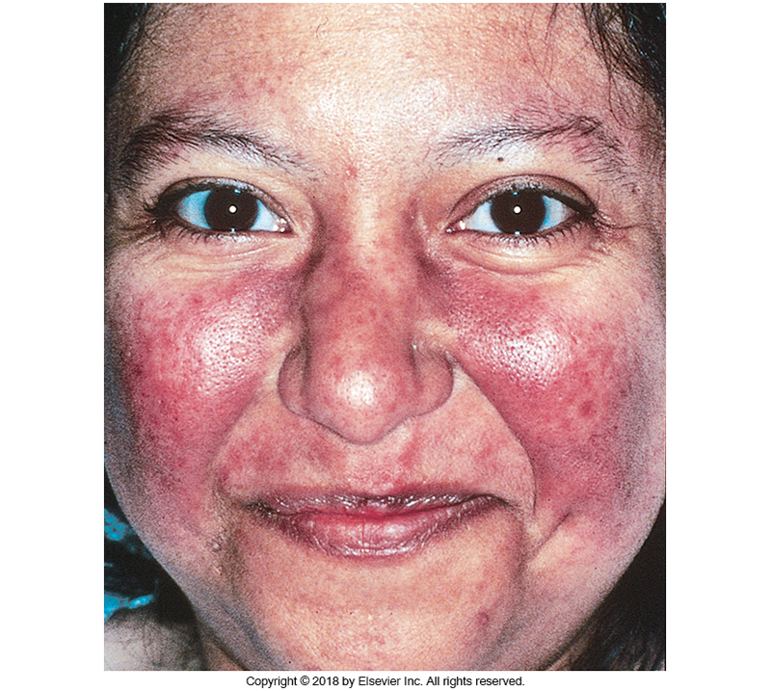
Using this picture and the information from your readings, what medical diagnosis do you believe this client has? Your instructor is going to break you into groups and based on the diagnosis you believe the client is experiencing research specific characteristics of the disorder and 3-4 medical and nursing interventions appropriate for this client.

